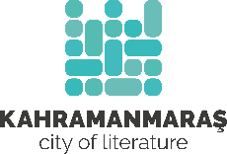
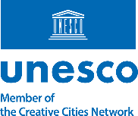

Call for Applications
Kahramanmaraş City of Literature
International Writers' Residency Program 2026

The Kahramanmaraş UNESCO City of Literature Office is pleased to announce its International Writers' Residency Program. Located in a city widely celebrated as the Capital of Poetry and Literature of Türkiye, the residency offers writers, poets, and literary translators the opportunity to dedicate time to their creative work while engaging with the rich literary, cultural, and historical heritage of Kahramanmaraş. The program welcomes applications from professional writers who are actively engaged in creative writing, poetry, literary translation, or related literary practices. Three residents will be selected. Priority consideration will be given to one applicant residing in a UNESCO City of Literature or demonstrating a strong connection to one or more UNESCO Cities of Literature.

What the Residency provides
Selected residents will receive:
- a stipend of €1,000 per resident
- free accommodation in a furnished private apartment in the city center
- access to dedicated workspaces at the Kahramanmaraş City of Literature offices, one located in the historic Mansion Köker Konağı and the other in the Yunus Emre Congress and Culture Center
- round-trip economy-class travel to and from Kahramanmaraş
- local transportation during arrival and departure

Opportunities
Residents will have the opportunity to:
- participate in literary events, such as readings and workshops
- meet local writers, poets, and other creative professionals
- explore the city's literary, historical, cultural, and natural heritage through guided visits and excursions
- give interviews to local and national media
- publish their work in literary magazines based in Kahramanmaraş, subject to editorial review

Residency Program Details
- Application Deadline: 15 August 2026
- Announcement of Selected Residents: 22 August 2026
- Residency Dates: 15 October – 15 November 2026
- Residency Duration: Four weeks
- Number of Residents: Three

Eligibility and Selection Criteria
Applicants should meet the following requirements:
- at least five years of creative writing, literary translation, or related literary experience
- at least two published books or equivalent literary publications
- upper-intermediate proficiency (B2 level or higher) in English or Turkish
- interest in Turkish culture, literature, and intercultural exchange
- willingness to actively participate in the residency program and public events

*Applications will be evaluated on the basis of artistic merit, professional experience, motivation, and the potential contribution of the applicant to the cultural life of the residency.

Resident Commitments
Selected residents are expected to:
- participate in at least three literary or cultural activities during their stay and engage with local audiences and the literary community
- produce a short creative work inspired by their residency experience in Kahramanmaraş. This may take the form of a poem, essay, short story, memoir, letter, illustrated work, or another creative format chosen by the resident.
- The completed work should be submitted at the end of the residency or no later than two months after its completion. Residents will retain copyright of the work. However, by participating in the program, residents grant the Kahramanmaraş UNESCO City of Literature Office a non-exclusive, royalty-free license to publish, reproduce, translate, and use the submitted work, as well as residency-related photographs, interviews, biographies, and other related materials for non-commercial cultural and promotional purposes, with full acknowledgement of authorship.

How to Apply

Please submit the following documents in English or Turkish to: creative_city_kahramanmaras@kmbb.bel.tr

Required documents:
- Completed application form
- Proof of at least two published books or equivalent literary publications
- Writing sample (2 pages, in Turkish or English)
Optional:
- Letter of recommendation
- Curriculum vitae or short biography
- Motivation letter

Should you have any questions regarding the residency program or the application process, please do not hesitate to contact us at the same email address.

We warmly encourage writers from diverse cultural, linguistic, and literary backgrounds to apply and look forward to welcoming new voices to Kahramanmaraş, Türkiye's first and only UNESCO City of Literature.

Residents will have access to a dedicated workspace at one of the Kahramanmaraş City of Literature offices, housed in the historic Köker Konağı Mansion and operating under the auspices of the Kahramanmaraş Metropolitan Municipality. The mansion hosts a variety of literary events and cultural programs throughout the year. It includes several small workspaces, a meeting room, a kitchen, and an inner courtyard. The office is situated close to the historic city center. Within walking distance, residents can immerse themselves in the daily life of traditional neighborhoods and wander through narrow streets where unexpectedly some old architectural gems await discovery.
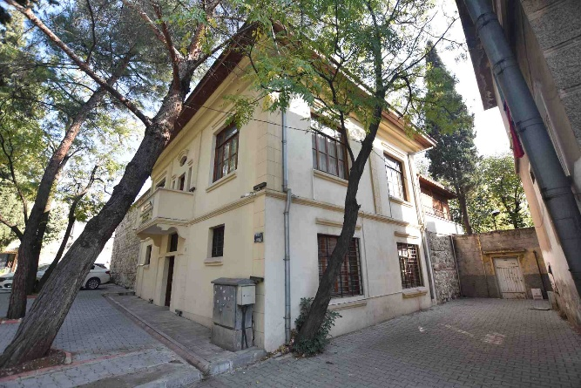
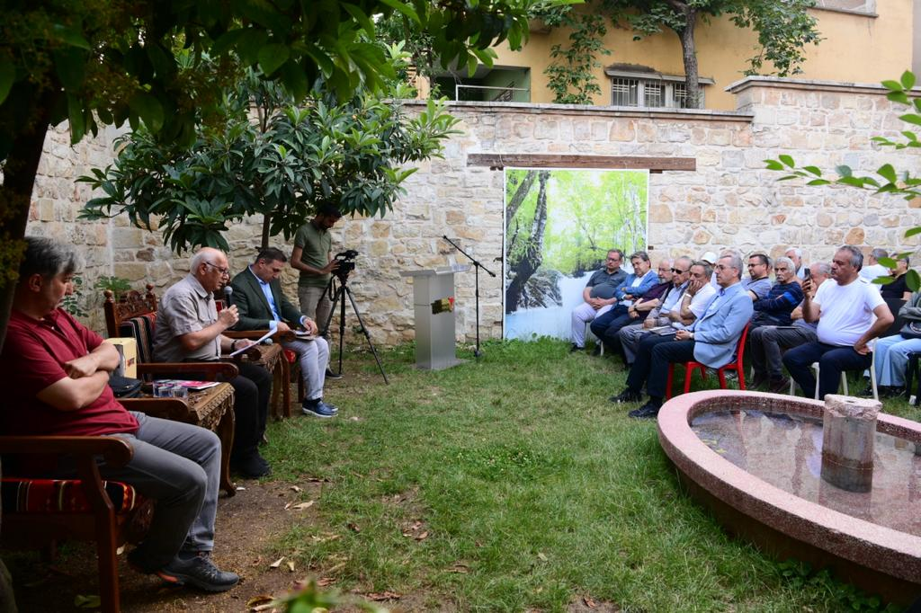

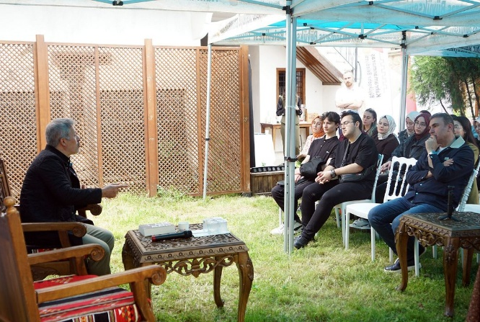
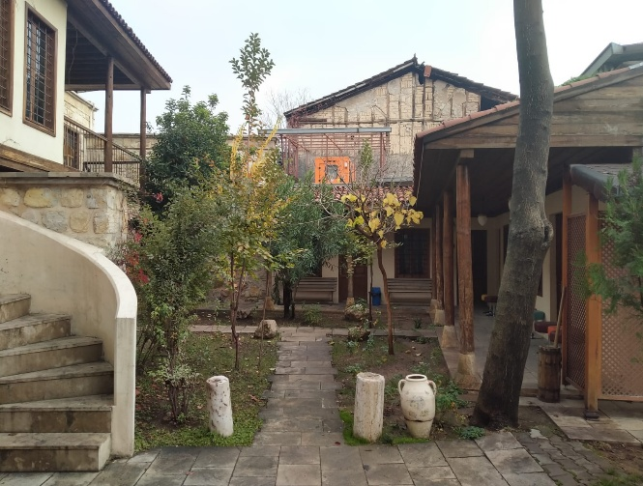

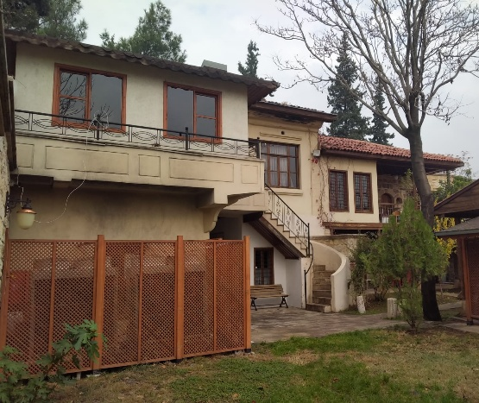
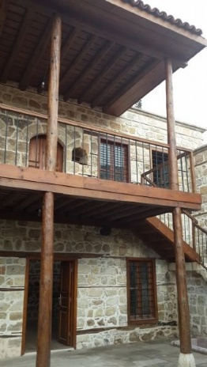
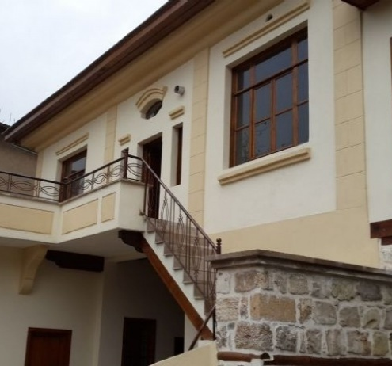

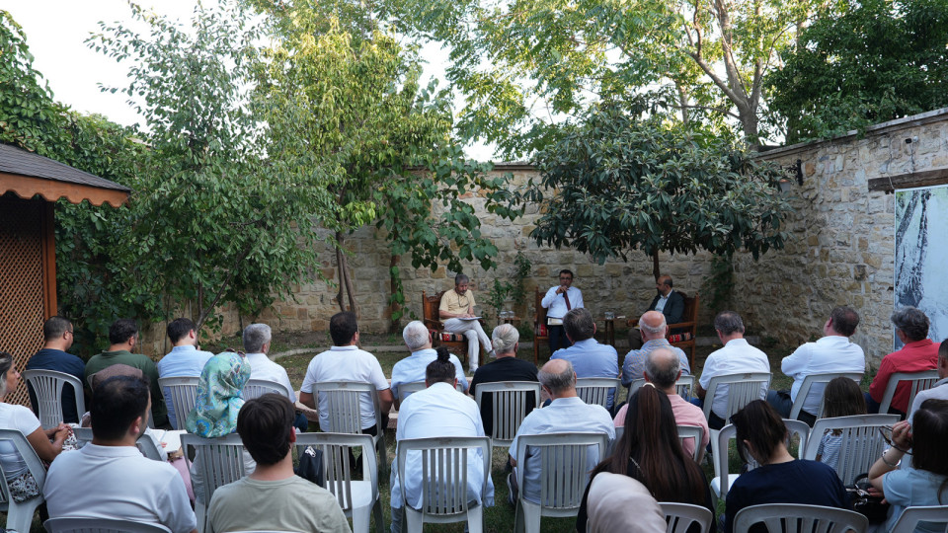

Residents will have access to a dedicated workspace at one of the Kahramanmaraş City of Literature offices, located in the Yunus Emre Congress and Culture Center on the campus of Kahramanmaraş Sütçü İmam University. The Center is situated next to the University's Library. Both the Center and the Library are designed to serve people with disabilities and support diverse accessibility needs. Residents can also enjoy nearby campus cafés, social spaces, and walking paths with views of the lake and mountains nearby.

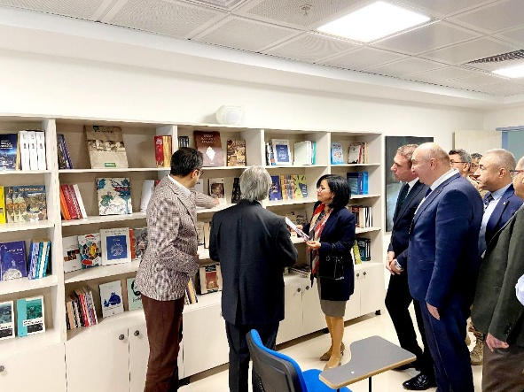
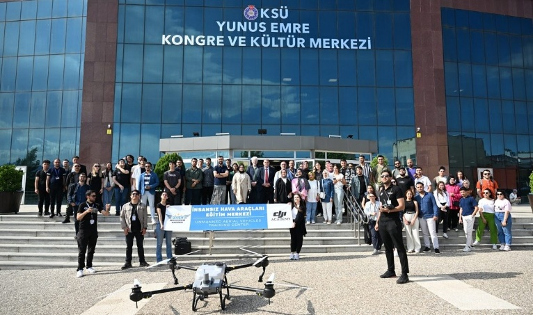

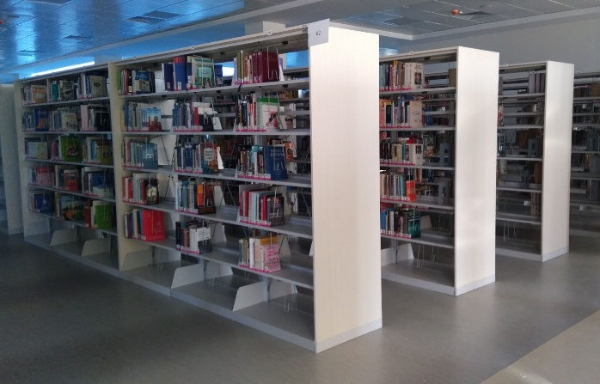
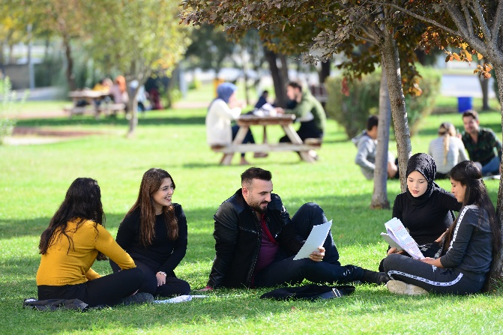

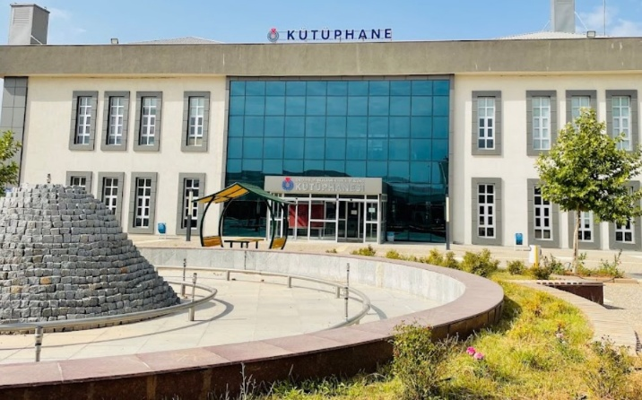
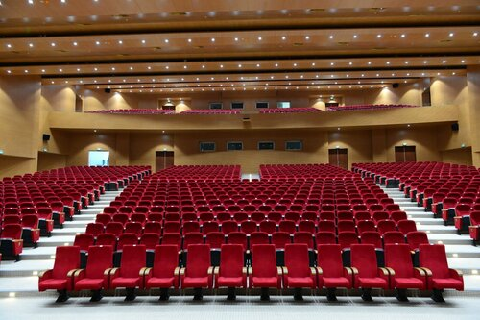

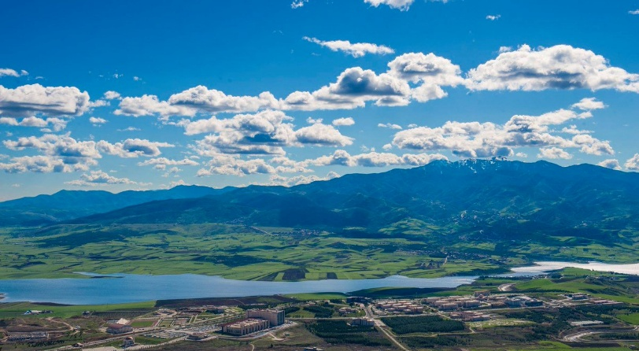

Literary Kahramanmaraş: The Capital of Poetry & Literature of Türkiye*

“In Maraş, you will find a poet in two out of every three homes.”

Kahramanmaraş is a vibrant center of literature, distinguished by its rich literary heritage and vibrant contemporary cultural life. It is no coincidence that Kahramanmaraş is widely known throughout Türkiye as the “Capital of Poetry and Literature”. The city’s literary heritage stretches back to the twelfth century through its traditions of classical poetry, folk literature, and minstrelsy. The city is associated with some of the most celebrated figures in Turkish literary history, including the Ottoman poet Sümbülzâde Vehbi, known as the “Sultan of Poets” in the divan tradition; Karacaoğlan and Âşık Mahzunî in folk literature; and modern literary figures such as Tahsin Yücel and Cahit Zarifoğlu. The city's oral storytelling tradition remains vibrant, and likewise, master minstrels continue to sustain the centuries-old Âşıklık tradition, a UNESCO-recognized element of intangible cultural heritage, blending music and poetry.

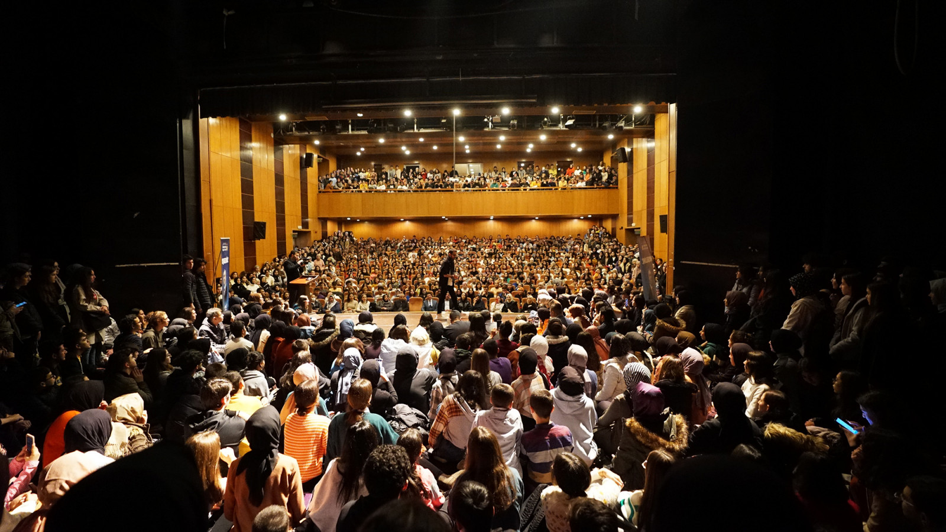

Over the past century, a remarkable magazine publishing tradition has flourished in the city, giving rise to numerous literary and cultural periodicals. This rich intellectual environment has contributed to what is often referred to as the Maraş école in modern Turkish literature. Today, literary magazines continue to play an important role in fostering creative expression, the exchange of ideas, and cultural participation. Alongside other literary works, these magazines form part of the city’s collective memory, preserving its literary traditions, cultural continuity, and diverse identities for future generations.

The Kahramanmaraş Metropolitan Municipality plays an active role in the city’s cultural life, publishing its own literary magazines, promoting literary excellence through its annual National Literature Awards, and celebrating literature throughout the year through major cultural events, including the International Poetry and Literature Days, the Minstrels and Poets Festival, the Book Fair, and the August Culture Fest, which collectively attract more than 1.5 million visitors annually.

Today, Kahramanmaraş brings together its deep-rooted literary traditions, rich cultural heritage, vibrant creative life, and growing modern economy, fostering dialogue, creativity, and cultural participation, inspiring new generations of writers, poets, and readers, and offering residents and visitors alike a distinctive cultural experience.

*Edebiyatın Başkenti Kahramanmaraş ® (The Capital of Literature Kahramanmaraş) is a registered mark officially recognized by the Turkish Patent and Trademark Institute. The Kahramanmaraş Metropolitan Municipality is the applicant and owner of this registered mark.

Creative Kahramanmaraş: The Pearl of the Mediterranean

Kahramanmaraş, located in the heart of the Eastern Mediterranean region of Türkiye, covers an area of 14,346 km² and is home to more than one million residents across its eleven municipalities. It has been shaped by numerous civilizations, including the Hittites, Romans, Seljuks, and Ottomans. Kahramanmaraş served also as the capital of the Neo-Hittite Kingdom of Gurgum, which endured for nearly five centuries before being incorporated into the Assyrian Empire. The city was also the capital of the Dulkadirid Principality, a powerful Anatolian state that ruled the region for nearly two centuries between the fourteenth and sixteenth centuries and later became part of the Ottoman Empire. Today, the Epipaleolithic Direkli Cave, the Cave of the Seven Sleepers on UNESCO’s Tentative World Heritage List, the remarkable mosaics of the ancient city of Germanicia, as well as its castles, historic mosques, tombs, and madrasas, bear witness to the city's rich and diverse history.

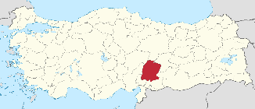
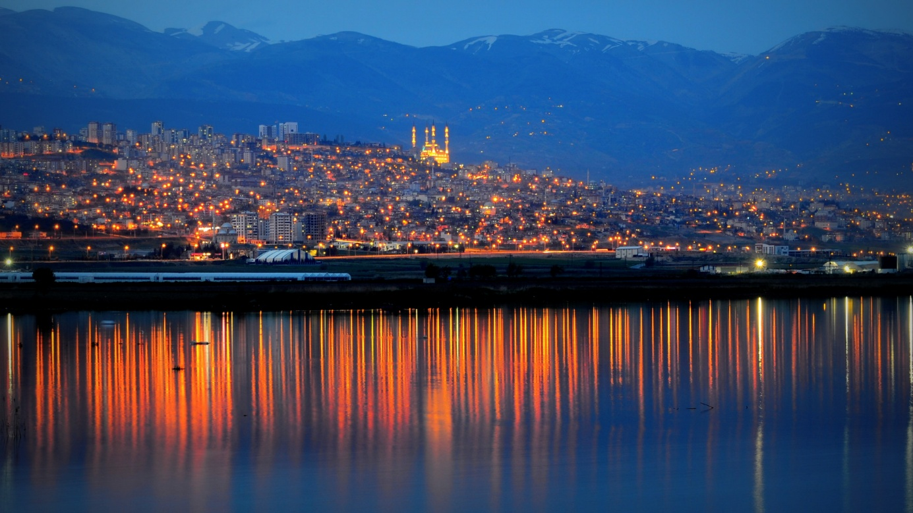

Kahramanmaraş is one of Türkiye's leading centres of traditional craftsmanship and is widely regarded as one of the country's foremost strongholds for the preservation and practice of traditional crafts, including gold-thread embroidery, wood carving, inlay work, coppersmithing, blacksmithing, and saddlery. Within its 600-year-old historic bazaar, which remains at the heart of the city’s economic and cultural life, skilled artisans continue to produce handcrafted yemeni shoes, one of the region’s most distinctive folk-art traditions. Renowned for their exceptional craftsmanship, the centuries-old tradition of yemenicilik remains a vibrant element of the city’s living cultural heritage. Its handmade footwear has even reached the international film industry, appearing in globally acclaimed productions.

Kahramanmaraş is also Türkiye’s second most important center for goldsmithing after Istanbul. In 2021, Altınşehir, the country’s largest gold and jewelry production center, was established in the city. Alongside this modern complex, which combines advanced manufacturing technologies with traditional craftsmanship, master goldsmiths continue to produce traditional Maraş Burma Bracelets, one of the city’s most distinctive handicrafts and a geographically indicated cultural product. This centuries-old tradition also remains an important symbol of the city’s artisanal heritage and craftsmanship.

In addition to its 25 registered elements of intangible cultural heritage and its rich cultural assets, Kahramanmaraş possesses a strong industrial base. The energy, food, iron and steel, textile, and paper industries play a significant role in the city’s economic development. With its substantial production capacity, employment opportunities, and entrepreneurial spirit, the city has emerged as an important regional center of economic activity and investment. The city is perhaps best known internationally for Maraş Ice Cream, a unique local specialty celebrated throughout Türkiye and beyond.

